[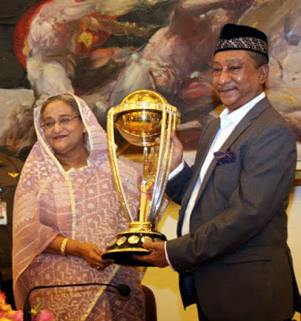](https://2.bp.blogspot.com/-9Xki-rqKbIQ/W8qf6mCC06I/AAAAAAAAATQ/lSQ7K-1hzIs8a2pC1dnK1xAQkZQ8ops-QCLcBGAs/s1600/BtYxzX-CYAA9A2A.jpg)

**ICC World Cup Trophy**

[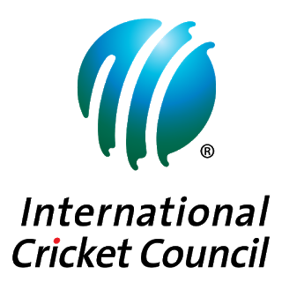](https://2.bp.blogspot.com/-IgMy9v7TtUE/W8qgLidqzAI/AAAAAAAAATY/dOysL7LsYv8KJiLRKG40B8azJ6ugqNbLgCLcBGAs/s1600/1200px-International_Cricket_Council_%2528logo%2529.svg%2B%25281%2529.png)

The **ICC World Cup Trophy Trip** will initiate its **nine-month trip** all over the the world on **Monday** beginning  from the [ICC](https://www.icc-cricket.com/) headquarters in **Dubai**.The trophy will travel through five regions, 21 nations and over 60 towns, creating it the **“most connected Trophy Tour ever”**, the ICC said in a release.

The trophy will stopover the **10 hostile nation**s at the World Cup -

* England
* South Africa
* India
* Australia
* New Zealand
* Pakistan
* Bangladesh
* Sri Lanka
* Afghanistan
* West Indies

[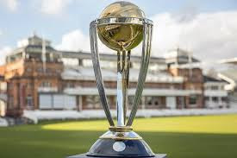](https://4.bp.blogspot.com/-8kkPtlR5AR0/W8qgdIlk9YI/AAAAAAAAATg/zxsNkYauz_EkYIIrVk1cEQdLnWV6DTEOwCLcBGAs/s1600/download.jpg)

It will correspondingly  **"go beyond traditional cricket heartlands"**  for the first time, according to the [ICC](https://www.icc-cricket.com/).

* Oman
* the United States
* Nepal
* Kenya
* Rwanda
* Nigeria
* France
* Belgium
* the Netherlands
* Germany

 -will also welcome the cup before it boards on a **100-day domestic  trip** in **England** and **Wales,** starting in **February**.

**Arrival On Bangladesh:**

The World Cup trophy  trip, driven by [Nissan](https://www.nissanusa.com/), will reach in Bangladesh **Wednesday** morning for a **four-day** stopover as part of its trip around the world.

Fans in **Dhaka**, **Sylhet** and **Chittagong** will acquire the chance to see the cup in their own towns before it leaves Bangladesh **Sunday**.

After Bangladesh, the cup will visit **Nepal**, **India, New Zealand,** **Australia, South Africa, Kenya,** **Rwanda, Nigeria, France, Belgium, the Netherlands** and **German**y beforehand reaching **England** and **Wales** on **February 19** afterward year.

[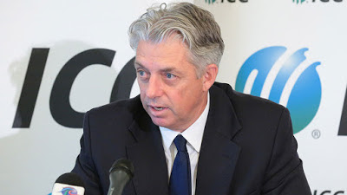](https://2.bp.blogspot.com/-rn7VCD179VU/W8qgt-E35kI/AAAAAAAAATo/eTTsYtQyYZMoQudJWOR0VEfQ1yfb1xo_wCLcBGAs/s1600/216403.3.jpg)

ICC Chief Executive [David Richardson](https://en.wikipedia.org/wiki/Dave_Richardson_(cricketer)) said the Cup Tour would provide a exclusive chance to fans. Richardson said in a statement-

The Trophy Tour is a unique opportunity for fans around the world to be part of the World Cup and by going to more countries and more cities than ever before we’re giving people more opportunities to be part of this fantastic sporting event

[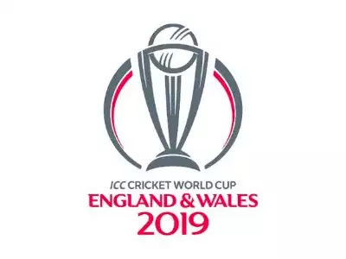](https://4.bp.blogspot.com/-imQ9Dr1SQ6g/W8qg7oeEs2I/AAAAAAAAATs/kPHCZLondrMijNRtnwU-S1njD6PKCB7XACEwYBhgL/s1600/63903187.jpg)

The competition will initiate on **May 30** next year when hosts **England** take on **South Africa** at The **Oval** in London.